**PTTSTAR AND  PRESENTS:**

**THE NEW ICOM LTE DISPATCH BASE WITH RDT-GPS**

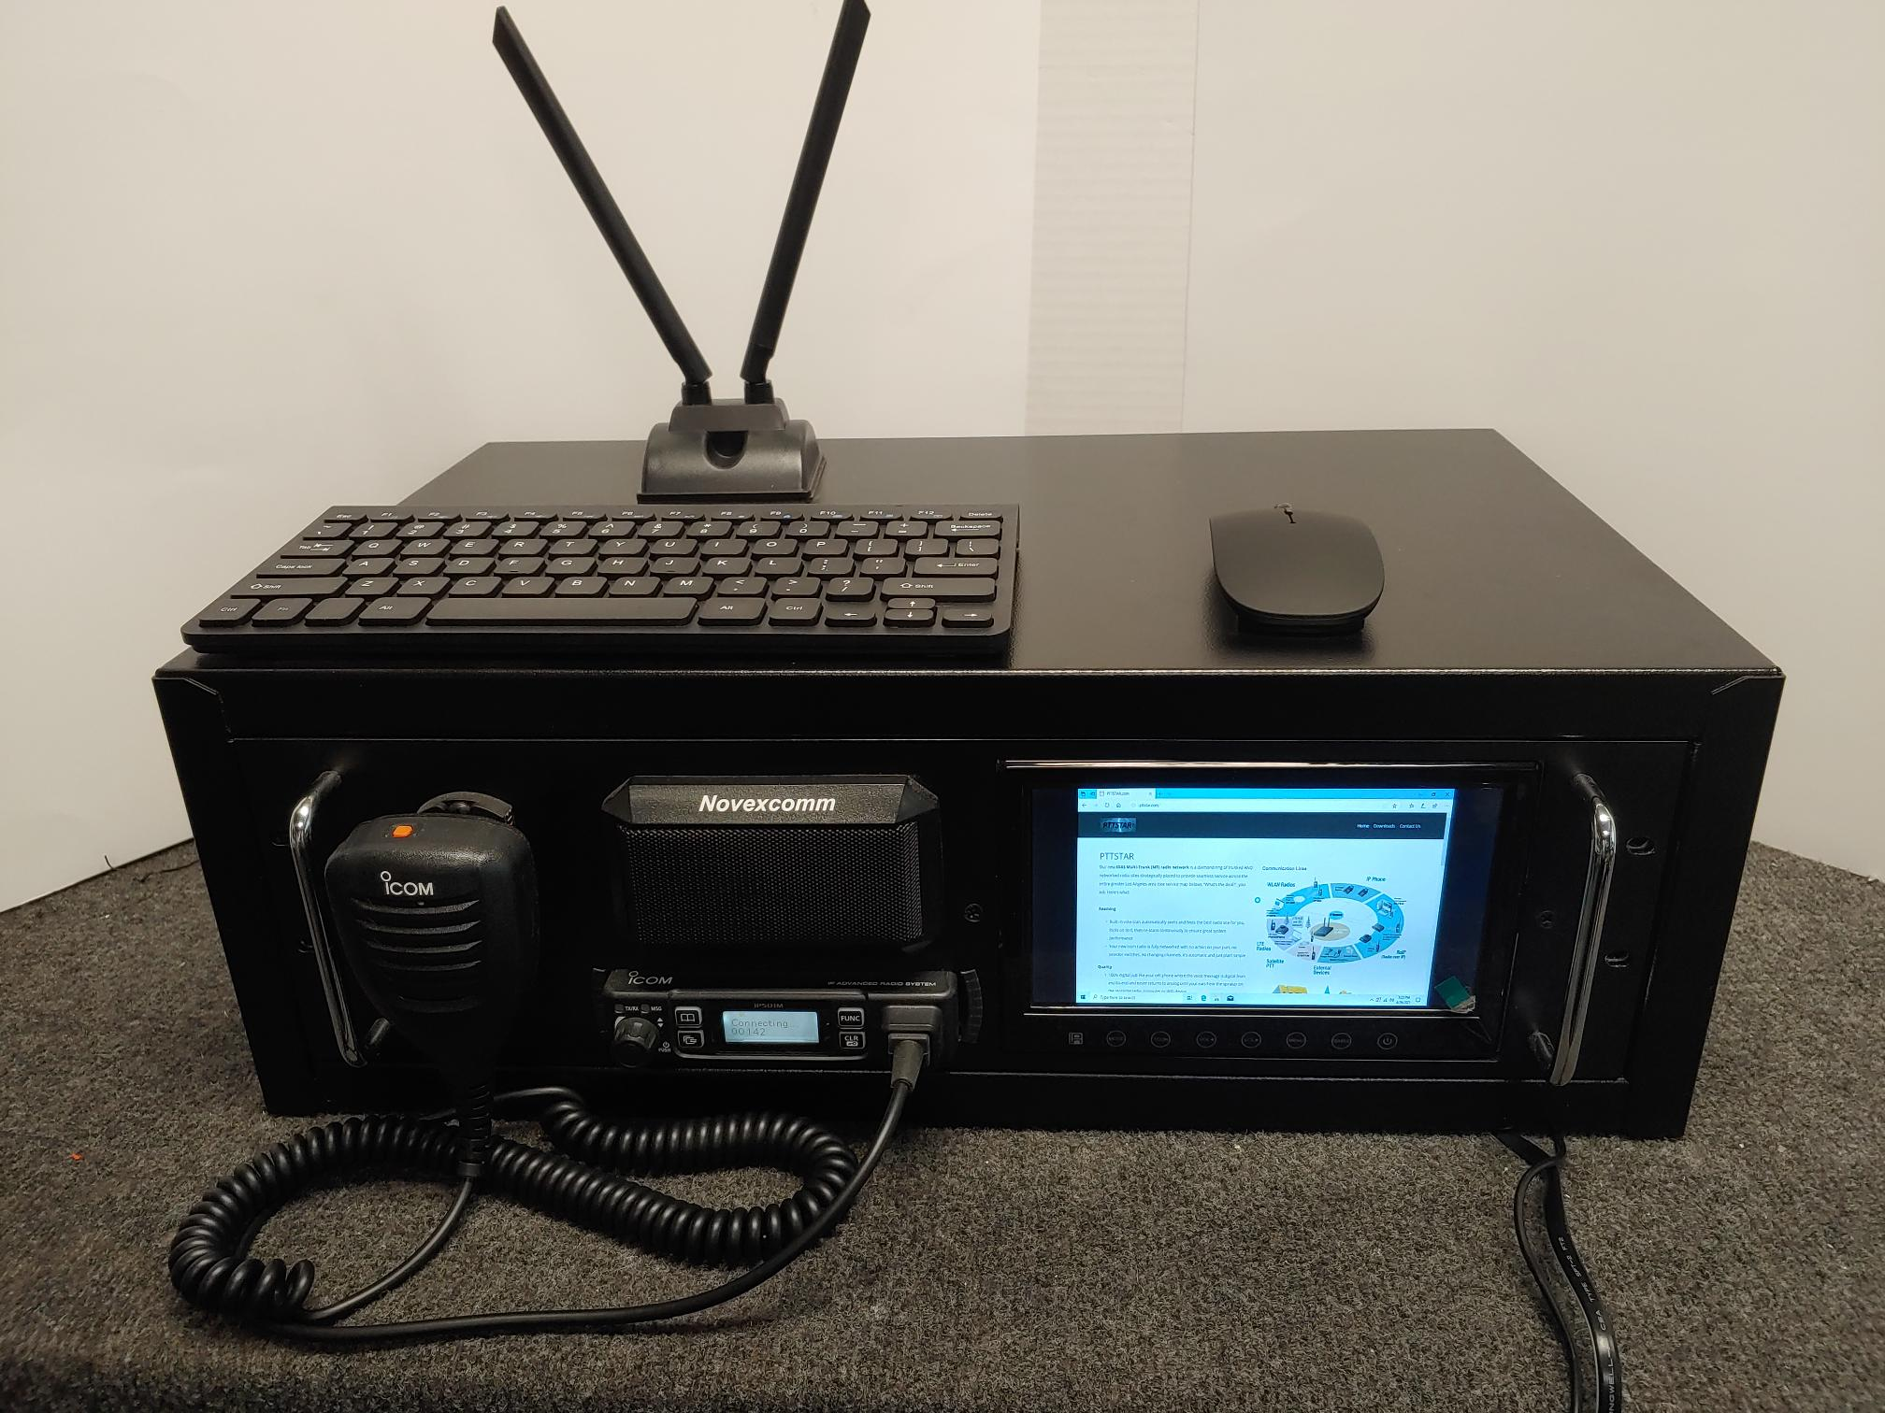

**FULLY INTEGRATED LTE 501M RADIO WITH MAGNET ANTENNA**

**WINDOWS 10 MICRO PC, WIRELESS KEYBOARD & MOUSE**

**7” HDMI HIGH-RESOLUTION MONITOR IS PERFECT FOR GPS**

**WIFI INTERNET CONNECTED & ICOM RDT-GPS INSTALLED**

**ONE AC POWER SUPPLY RUNS EVERYTHING WITH ONE CORD**

**POWER IT UP AND DISPATCH WITH INSTANT GPS DISPLAY**

**SEE MORE AT** [**WWW.PTTSTAR.COM**](http://WWW.PTTSTAR.COM) **FOR YOUR ICOM-CENTRIC PTT! CALL BOB AT 310.534.4456 FOR MORE INFO TODAY**